**Assignment 08**

**KD1-Indrajeet-86641**

Q1. Assume each salesperson has a 12% commission. Write a query on the orders table that will produce the order number, the salesperson number, and the amount of the salesperson’s commission for that order.

🡺 **select onum, snum, amt*0.12 from orders;**

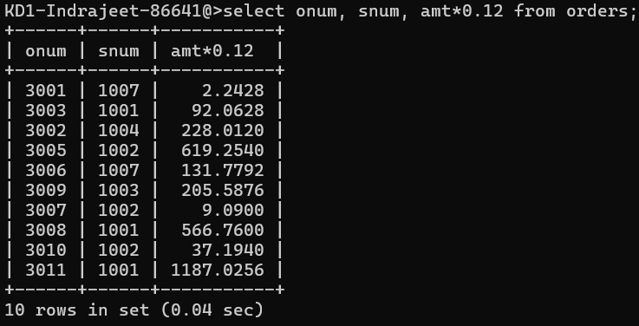

Q2. Write a query on the Customers table that will find the highest rating in each city. Put the output in this form: For the city (city), the highest rating is: (rating).

🡺 **select city, max(rating) as rating from customers;**

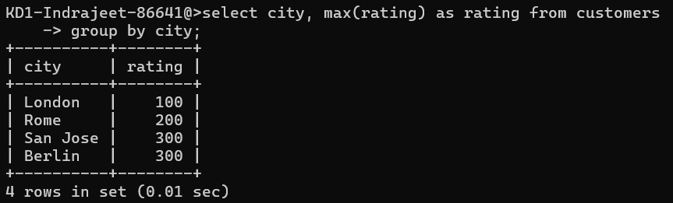

Q3. Write a query that lists customers in descending order of rating. Output the rating field first, followed by the customer’s name and number.

🡺 **select rating, cname as customer_name, cnum as customer_number**

**from customers order by rating desc;**

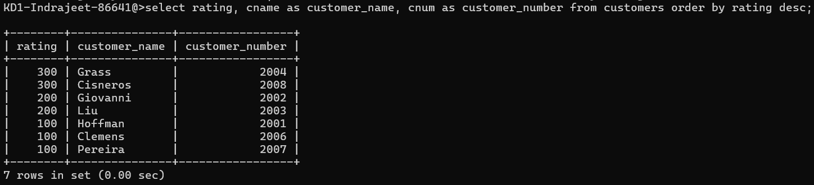

Q4. Write a query that totals the orders for each day and places the results in descending order.

🡺 **select odate, count(onum) as total from orders**

**group by odate order by count(onum) desc;**

